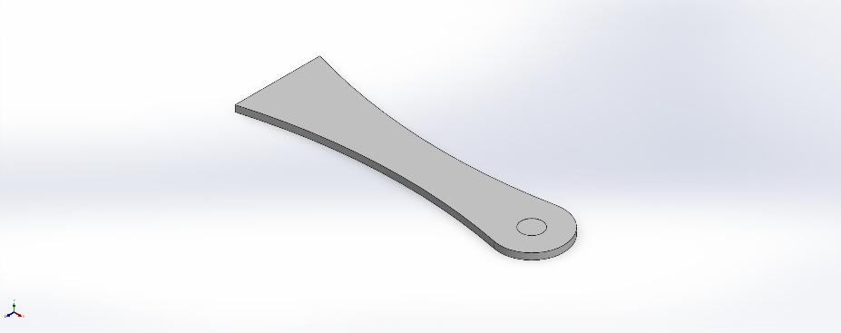 | Simulation of Drone Arm A  Date: Tuesday, July 28, 2026  Designer: Solidworks  Study name: Static 1  Analysis type: Static  Table of Contents  Description 1  Assumptions 2  Model Information 2  Study Properties 3  Units 3  Material Properties 4  Loads and Fixtures 5  Connector Definitions 5  Interaction Information 6  Mesh information 7  Sensor Details 8  Resultant Forces 8  Beams 8  Study Results 9  Conclusion 11

Description
No Data

Assumptions

Model Information

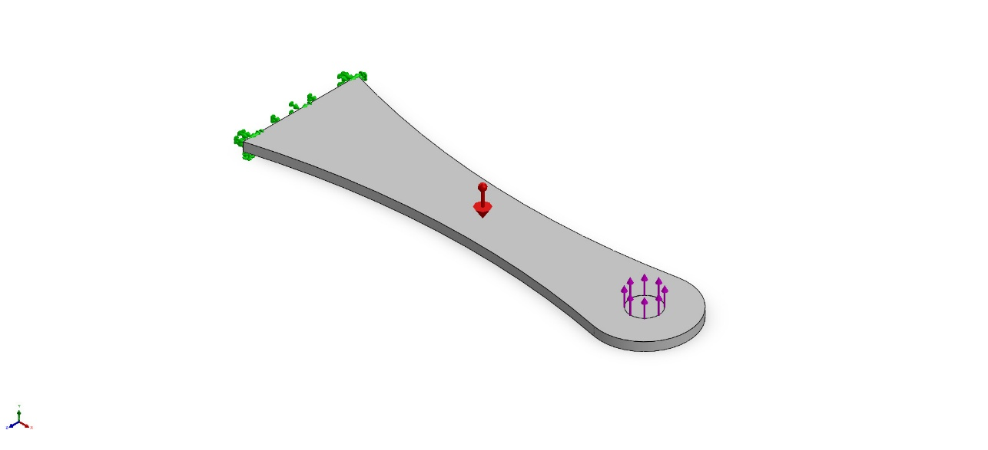
Model name: Drone Arm A
Current Configuration: Default
Solid Bodies
Document Name and Reference | Treated As | Volumetric Properties | Document Path/Date Modified
Boss-Extrude2  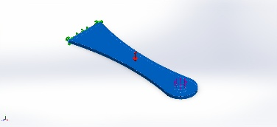 | Solid Body | Mass:0.0106609 kg  Volume:1.01533e-05 m^3  Density:1,050 kg/m^3  Weight:0.104477 N | C:\Users\gorlo\Documents\MATLAB\Mathworks MATLAB Challenge\EPPDronePayloadTeam7\Drone Project CAD\Drone Arm A.SLDPRT  Jul 28 14:13:17 2026

Study Properties
Study name | Static 1
Analysis type | Static
Mesh type | Solid Mesh
Thermal Effect: | On
Thermal option | Include temperature loads
Zero strain temperature | 298 Kelvin
Include fluid pressure effects from SOLIDWORKS Flow Simulation | Off
Solver type | Automatic
Inplane Effect: | Off
Soft Spring: | Off
Inertial Relief: | Off
Incompatible bonding options | Automatic
Large displacement | On
Compute free body forces | On
Friction | Off
Use Adaptive Method: | Off
Result folder | SOLIDWORKS document (C:\Users\gorlo\Documents\MATLAB\Mathworks MATLAB Challenge\EPPDronePayloadTeam7\Drone Project CAD)

Units
Unit system: | SI (MKS)
Length/Displacement | mm
Temperature | Kelvin
Angular velocity | Rad/sec
Pressure/Stress | N/m^2

Material Properties
Model Reference | Properties | Components
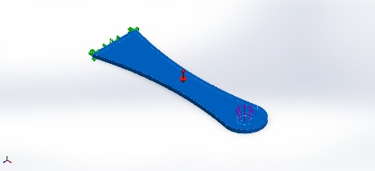 | Name: Custom Plastic  Model type: Linear Elastic Isotropic  Default failure criterion: Unknown  Yield strength: 4e+07 N/m^2  Tensile strength: 3e+07 N/m^2  Elastic modulus: 2e+09 N/m^2  Poisson's ratio: 0.35  Mass density: 1,050 kg/m^3  Shear modulus: 3.189e+08 N/m^2 | SolidBody 1(Boss-Extrude2)(Drone Arm A)
Curve Data:N/A

Loads and Fixtures
Fixture name | Fixture Image | Fixture Details
Fixed-1 | 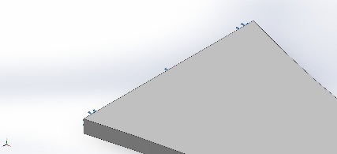 | Entities: 1 face(s)  Type: Fixed Geometry
Resultant Forces
Components | X | Y | Z | Resultant
Reaction force(N) | 9.69172e-05 | -8.96675 | 0.000182435 | 8.96675
Reaction Moment(N.m) | 0 | 0 | 0 | 0

Load name | Load Image | Load Details
Force-1 | 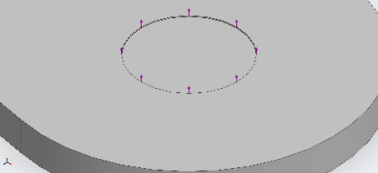 | Entities: 1 face(s)  Type: Apply normal force  Value: -0.73575 N
Force-2 | 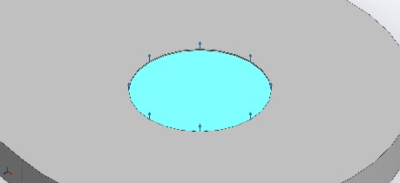 | Entities: 1 face(s)  Type: Apply normal force  Value: -1 kgf
Gravity-1 | 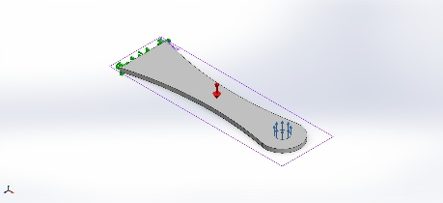 | Reference: Top Plane  Values: 0 0 -9.81  Units: m/s^2

Connector Definitions
No Data

Interaction Information
No Data

Mesh information
Mesh type | Solid Mesh
Mesher Used: | Blended curvature-based mesh
Jacobian points for High quality mesh | 16 Points
Maximum element size | 1.45617 mm
Minimum element size | 1.45617 mm
Mesh Quality | High

Mesh information - Details
Total Nodes | 48426
Total Elements | 29978
Maximum Aspect Ratio | 14.874
% of elements with Aspect Ratio < 3 | 99.4
Percentage of elements with Aspect Ratio > 10 | 0.307
Percentage of distorted elements | 0
Time to complete mesh(hh;mm;ss): | 00:00:02
Computer name: | NEPNEP

Mesh Quality Plots
Name | Type | Min | Max
Quality1 | Mesh | - | -
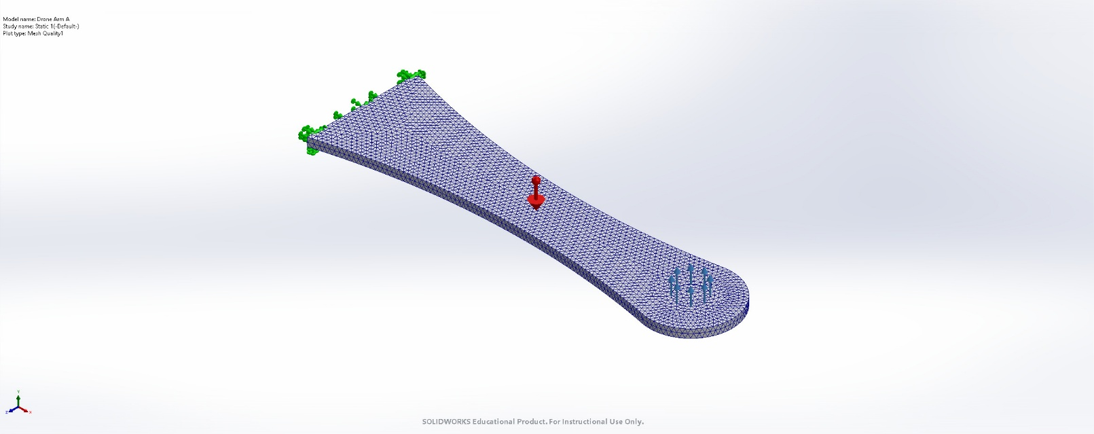
Drone Arm A-Static 1-Quality-Quality1

Sensor Details
No Data

Resultant Forces

Reaction forces
Selection set | Units | Sum X | Sum Y | Sum Z | Resultant
Entire Model | N | 9.69172e-05 | -8.96675 | 0.000182435 | 8.96675

Reaction Moments
Selection set | Units | Sum X | Sum Y | Sum Z | Resultant
Entire Model | N.m | 0 | 0 | 0 | 0

Free body forces
Selection set | Units | Sum X | Sum Y | Sum Z | Resultant
Entire Model | N | 0 | 0 | 0 | 0

Free body moments
Selection set | Units | Sum X | Sum Y | Sum Z | Resultant
Entire Model | N.m | 0 | 0 | 0 | 0

Beams
No Data

Study Results

Name | Type | Min | Max
Stress1 | VON: von Mises Stress | 1.661e+04N/m^2  Node: 18808 | 2.027e+07N/m^2  Node: 40148
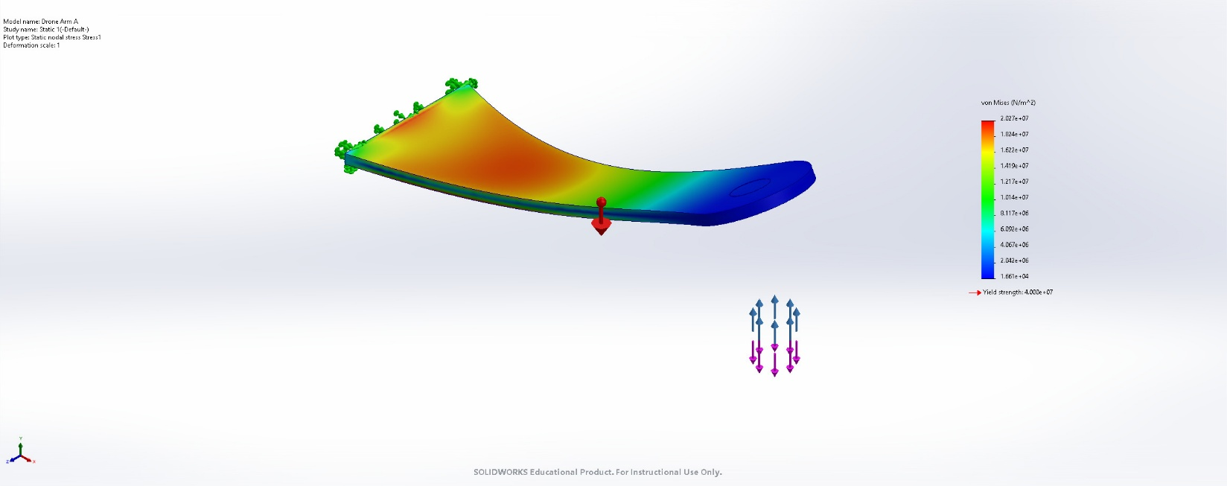
Drone Arm A-Static 1-Stress-Stress1

Name | Type | Min | Max
Displacement1 | URES: Resultant Displacement | 0.000e+00mm  Node: 6 | 4.474e+01mm  Node: 2034
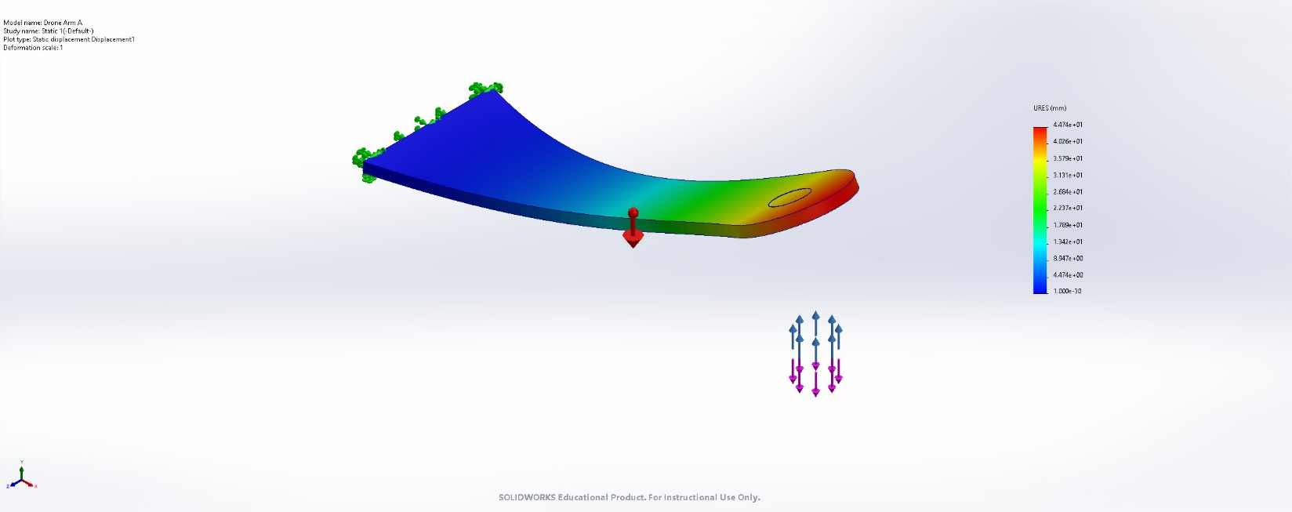
Drone Arm A-Static 1-Displacement-Displacement1

Name | Type | Min | Max
Strain1 | ESTRN: Equivalent Strain | 7.909e-06  Element: 20778 | 7.768e-03  Element: 1585
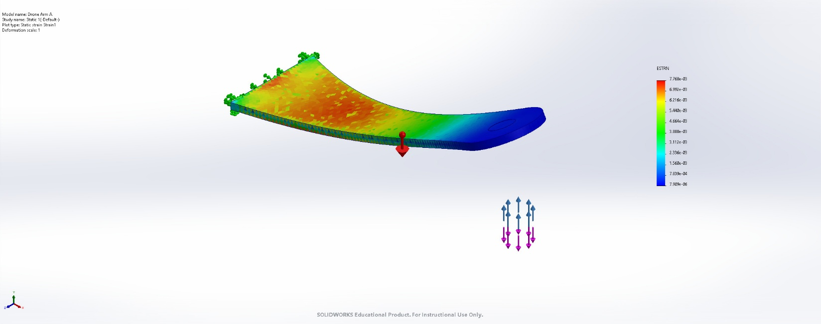
Drone Arm A-Static 1-Strain-Strain1

Name | Type
Displacement1{1} | Deformed shape
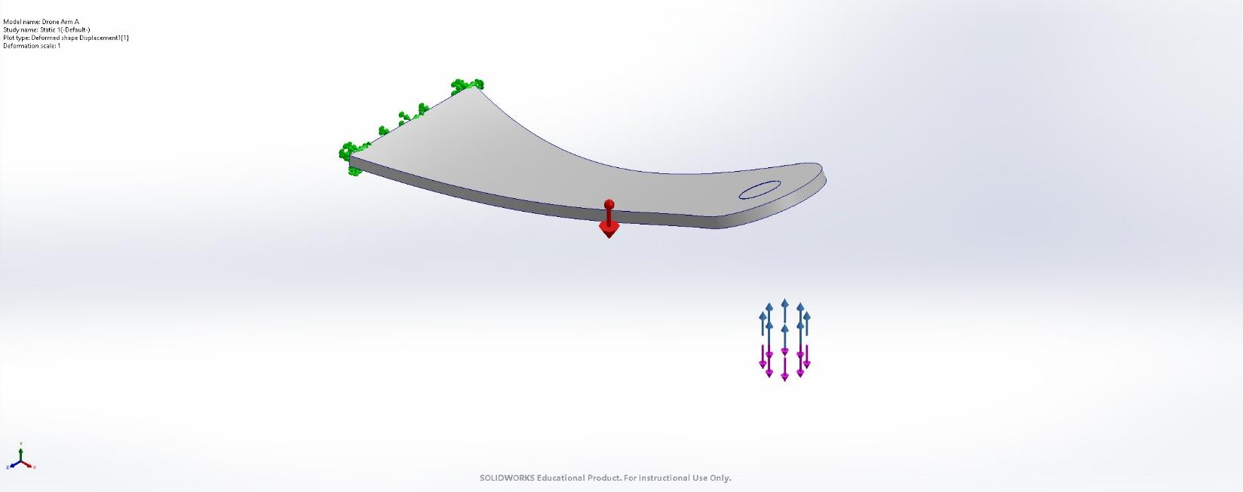
Drone Arm A-Static 1-Displacement-Displacement1{1}

Name | Type | Min | Max
Factor of Safety1 | Max von Mises Stress | 9.868e+01  Node: 40148 | 1.204e+05  Node: 18808
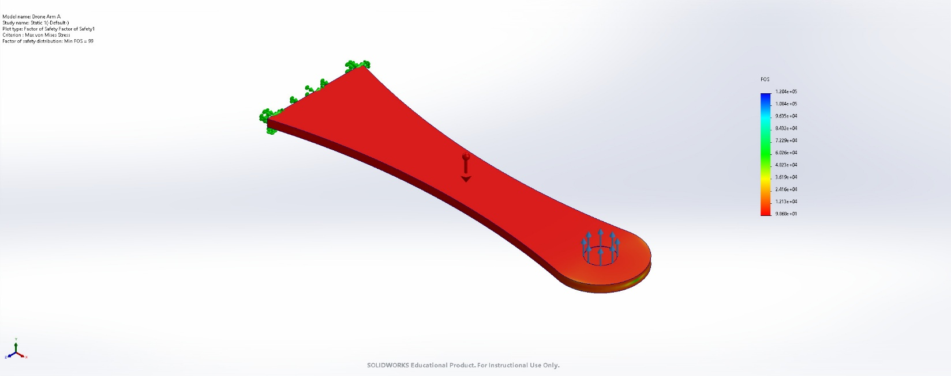
Drone Arm A-Static 1-Factor of Safety-Factor of Safety1

Conclusion

